Login to : <https://auth0.com/>

Credentials: Gmail Credentials

Provide **tenant-name** for creating tenant domian.

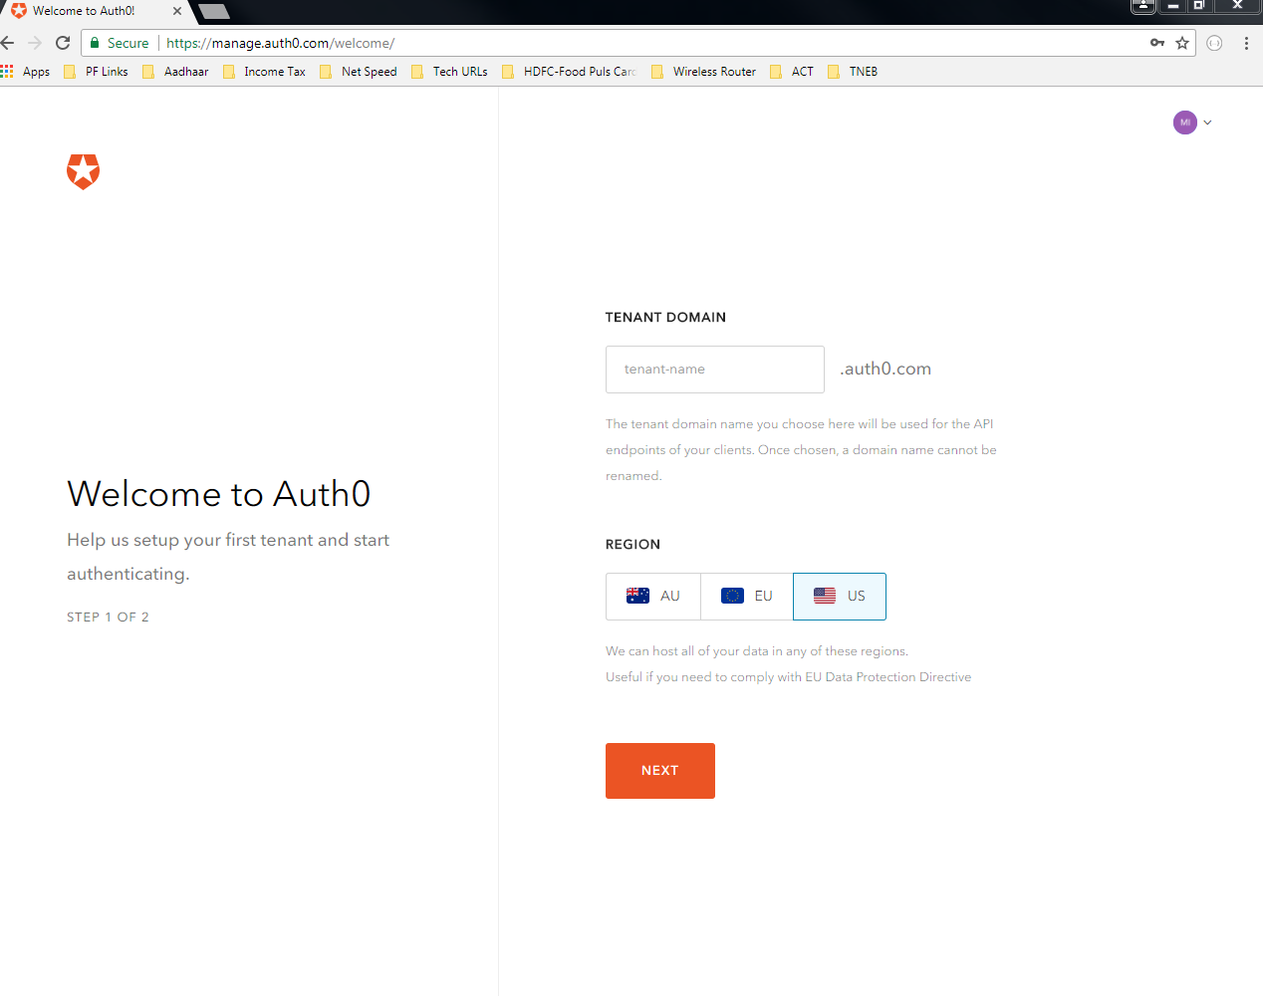

If you give **tenant-name** as **‘philomin’** then domain name will be constructed as ‘**philomin.auth0.com’**

This name can’t be changed and later will be used for the endpoint exposed.

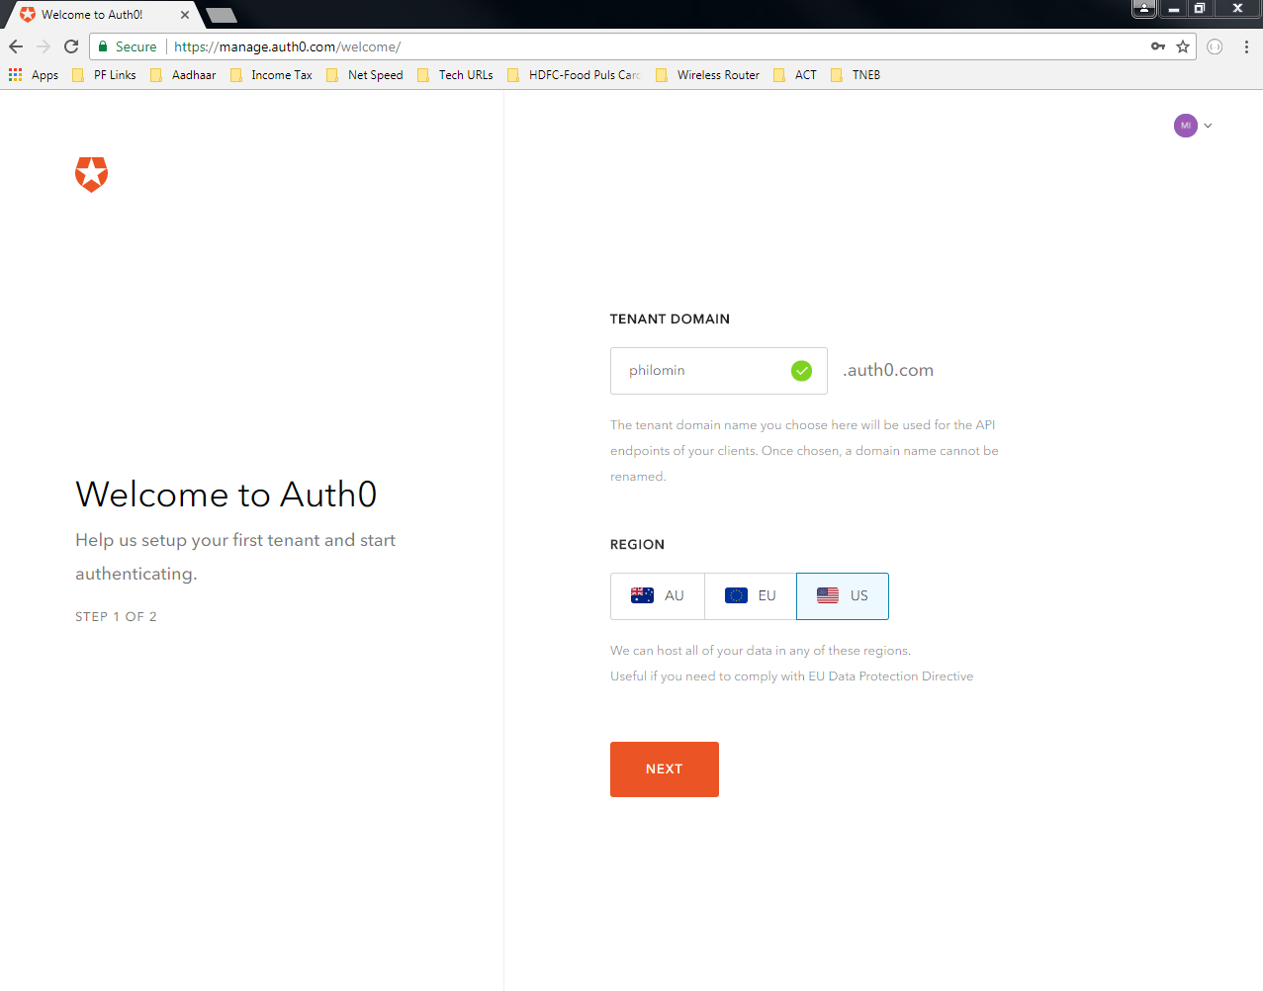

Select ACCOUNT TYPE as ‘Personal’ for own use

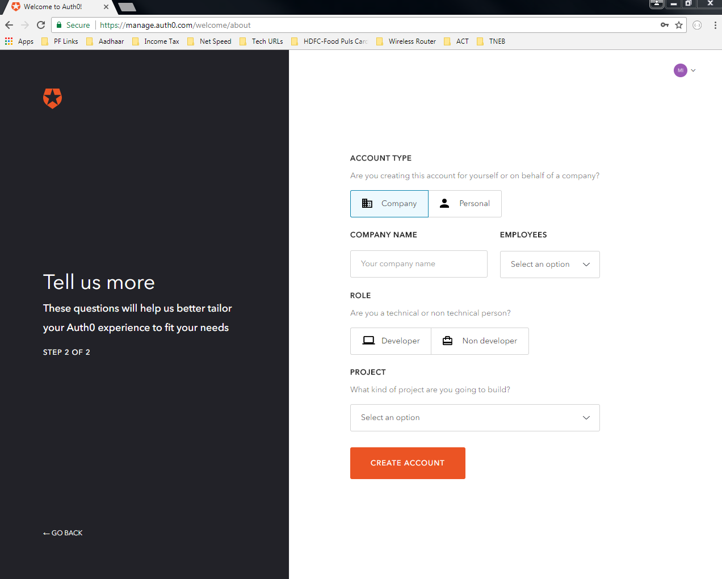

And then ROLE as ‘Developer’

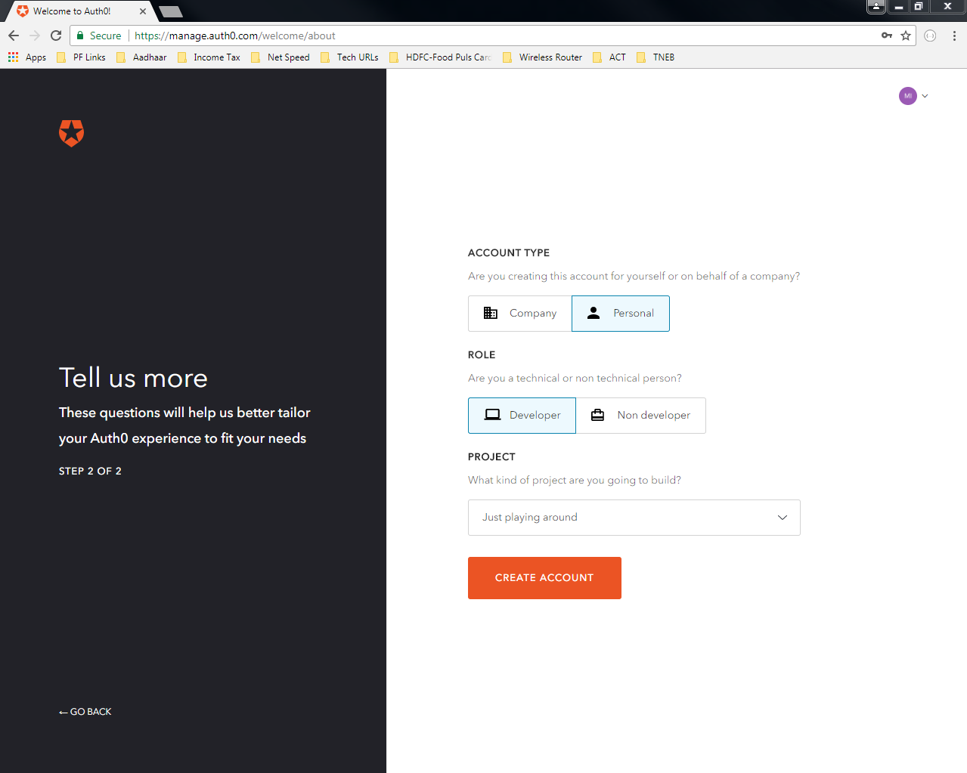

And then PROJECT as ‘Jjust playing around’

Now your account will be created as follows,

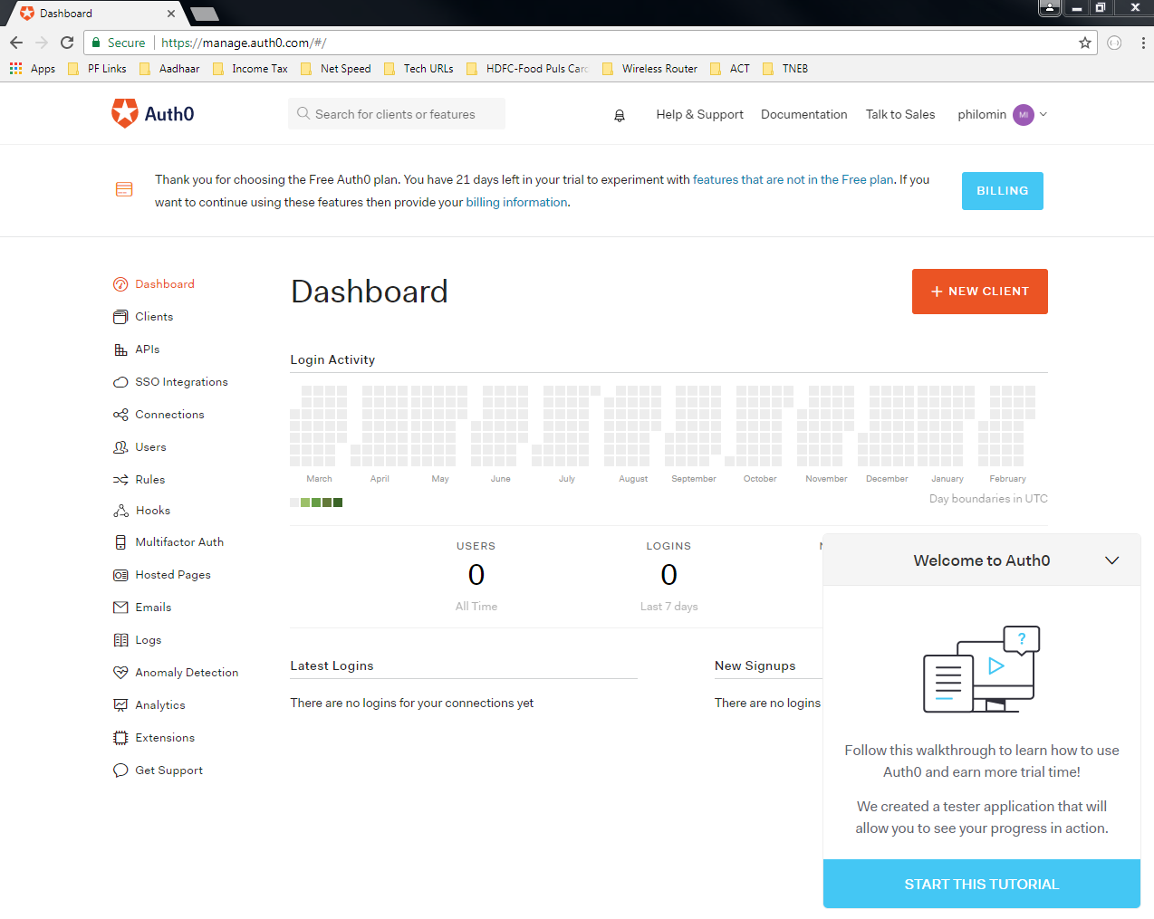

Click on ‘CREATE CLIENT’

Note: Client is same as your Application

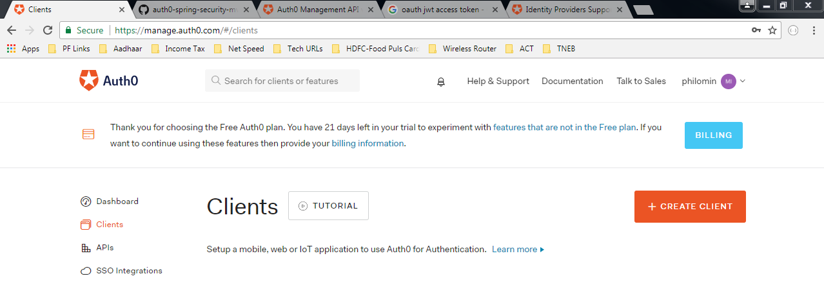

Then select type of Application as follows and create the client

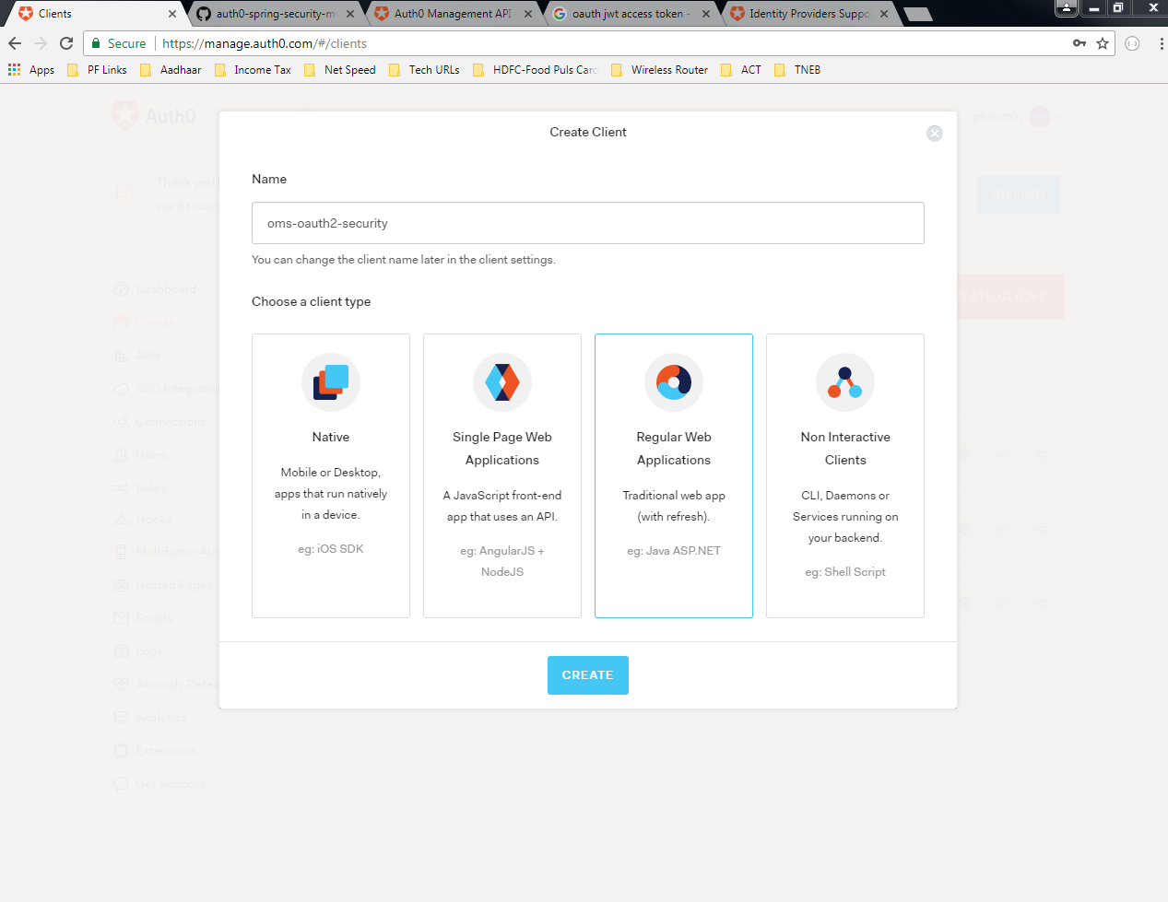

Select ‘Java Spring Security’ or the other releveant project based on the requirement and download the sample code for referrence

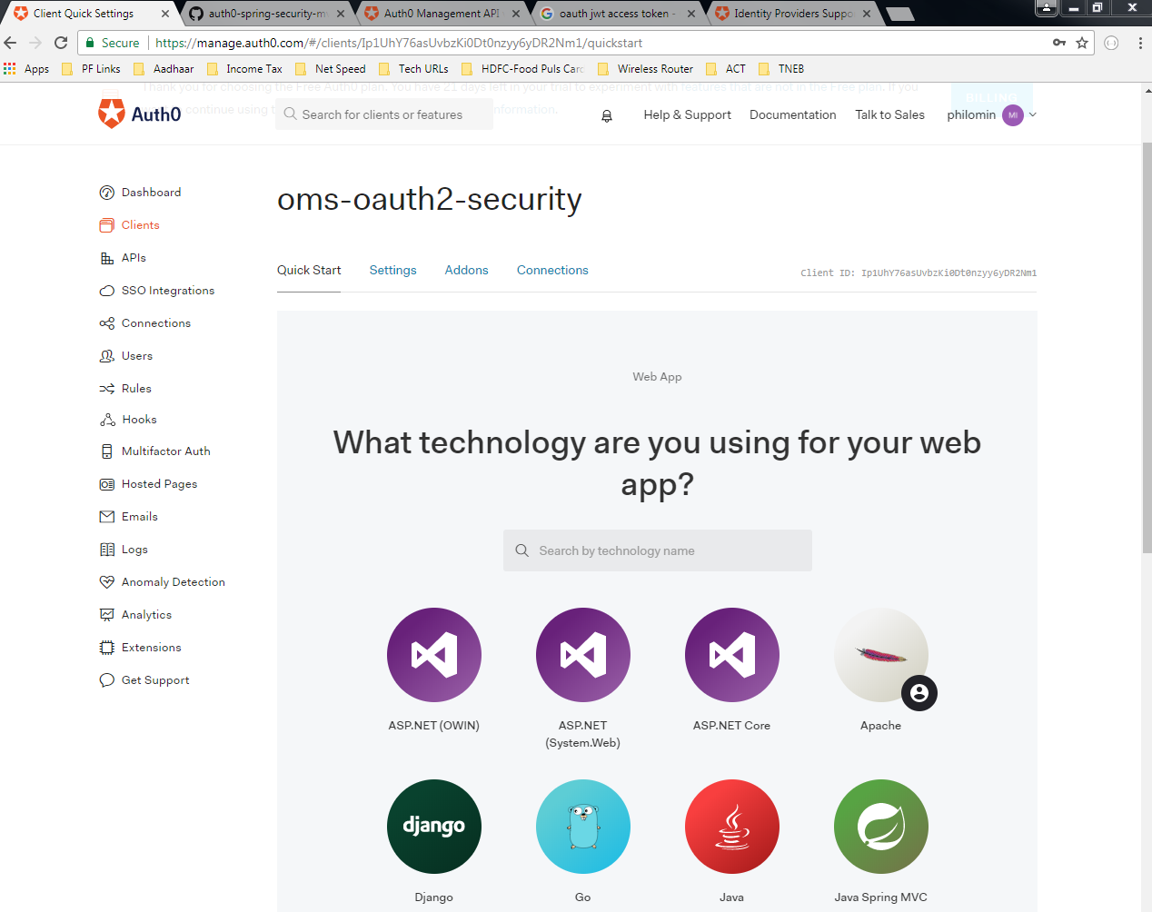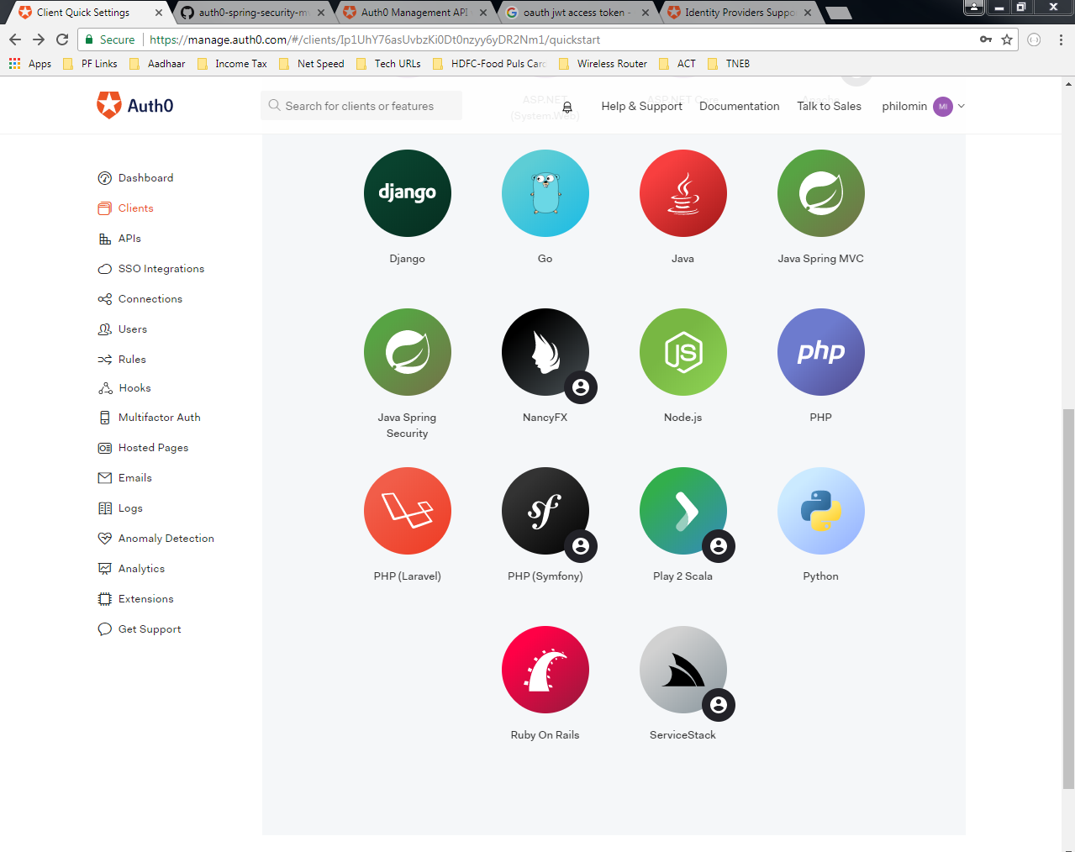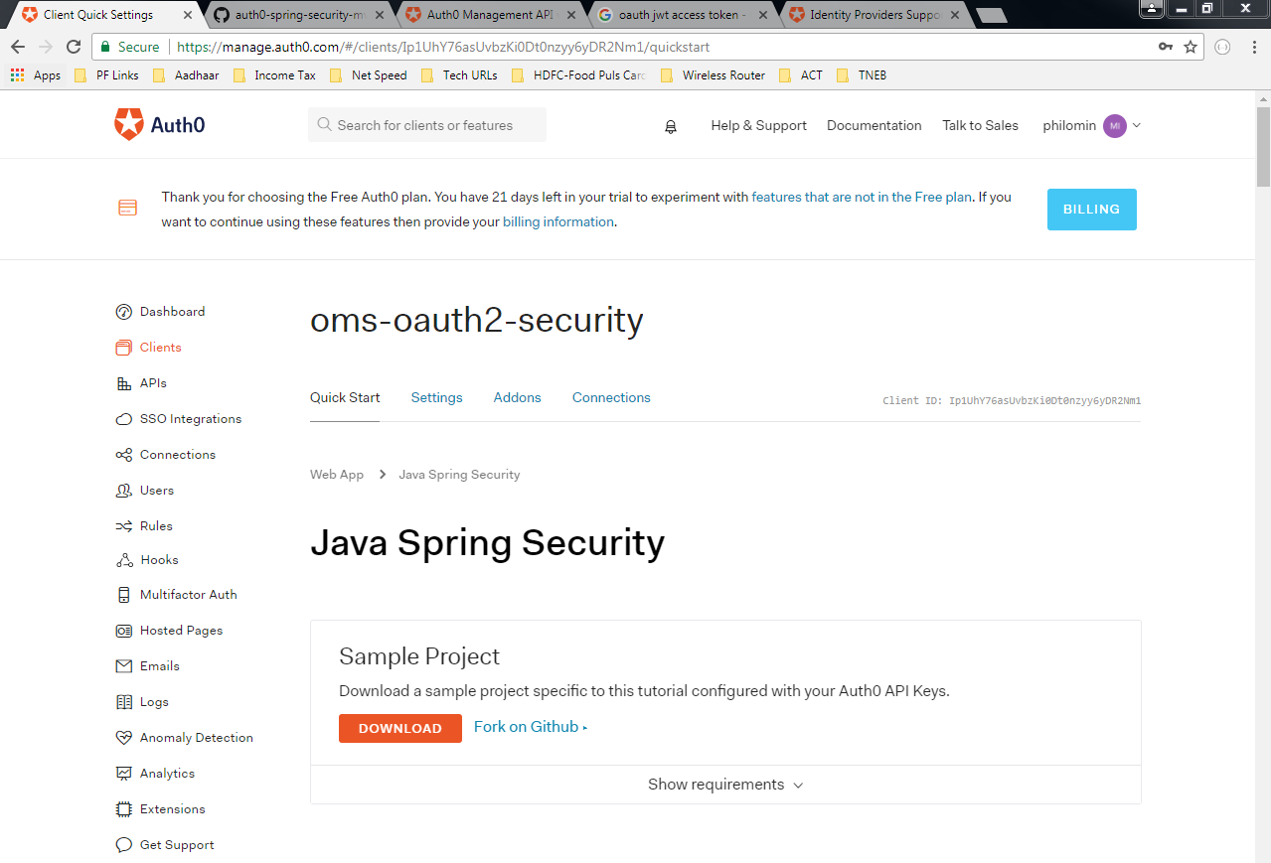

Select the created client and go the ‘Settings’ tab, you can see the following details

Some are prepopulated but some details you neeed to fill in.

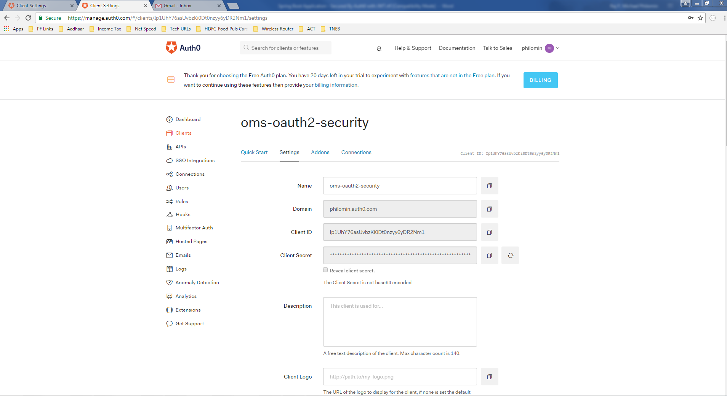

Set up the call back and log out URLs as follows

The URLs may vary to different enviroments

